**CS 5551**-**Project Plan**

**E-Smart Application**

Megha Sharma

Pavani Penumathsa

Reshma Reddy

Vinutha Nuchimaniyanda

**1. Introduction**

Utility bill is the amount a household has to pay for its electricity, gas or water utilization every month. High Utility bills are increasingly becoming the de-facto standard for many households in United States. An average American household spends $5,550/year on energy.

Buying appliances that are energy efficient, making home improvements, and taking energy-conservation actions every single day can save significant amount of money. While energy efficiency helps save money at home, it also helps businesses thus city, state and federal governments save on a much bigger scale. Overall, energy efficiency can save the American government, its citizens and businesses more than $500 billion a year by saving energy. When we use less energy, we save precious natural resources and cut down on pollution.

**2. Project Goal and Objectives:**

**Overall Goal**

Our goal is to develop a website/app which will help the user reduce his energy consumption by means of a recommendation system, plan his yearly budget, motivate them by means of reward points and helping each other through discussion forums

**Significance**

While there are so many clear advantages of saving energy however there are not many apps in the market which can effectively guide the users through the process. The major shortcomings that any such solution suffers from is the failure to create awareness and motivation and lack of effective guiding tools .We believe that educating people about the benefits of saving energy can go a long way in not just reducing the utility cost for users but also conserving our natural resources. So, we decided to develop an application that effectively analyses the utility data for the users while providing recommendations and at the same time encourage them to set goals, make commitments to achieve their energy-saving goals and motivate them to save energy and thus, their money. No motivation works better than peer pressure, one way of achieving this is through comparison of one’s energy savings with others in a community and awarding reward points to every household in the neighborhood based on their energy savings. Indulging users in discussion forums where people constantly talk about their energy goals and savings, share tips which will provide encouragement to save energy. Research says that 9 to 10 percent energy saving is achieved by goal oriented people. People set up a goal and communicate to someone else that they’ve made that commitment, and that’s a powerful motivator to help them reach their goals. Business owners and Families are constantly in search for ways to save their money. Cutting back costs on energy by upgrading to solutions that are more energy-efficient have been a proven method to see long-term saving

**3. Proposed System:**

Below are the proposed features of the application.

**Energy Analyzer**

Compares and analyses energy utilization with weather conditions. Energy analyzer provides the analysis of the user’s energy consumption based on his utility bills. It provides user the option to get his energy analysis on daily basis or weekly basis. For example, on a cold day the bill was high because the heater was switched on for longer than usual.

**Home Comfort**

* This provides the user suggestions about setting the temperature inside the house depending upon his comfort level.
* This can economical too if he does not want to his bill to be above a certain amount, then it provides him more suggestions i.e. to layer up if it is too cold.

**Recommendations for the user**

**Recommendation System**: Recommendation for the user on how to cut down utility bill.

* Once the energy analysis is done, the Recommendation system provides user the list of suggestions to cut down his energy consumption in future.

**Tip of the day:** This feature provides the users with simple ideas on how to reduce energy consumption.

Example:

* Set the heater temperature low while sleeping.
* This feature would be set as one tip each day

**Discussion Board**

**Discussion Forum**: Users can discuss with each other, the various ways to cut down their costs.

* All users can post their experiences, which could help others to plan on energy saving. The users can also post their problems so that other users can provide suggestions.
* Example: One user bought an energy efficient appliance; he could share his experience with others.

**Motivation for the user**

To avail the below features the user has to register:

**My Neighborhood**: The energy saving are translated to points and users can see the points of every household in his neighborhood.

* This feature is to encourage each household in a neighbourhood to collect some points based on their energy savings.
* The user can view the points accumulated by other households in the neighbourhood which would motivate him to gain more points.

**Household of the Month:** Based on points accrued by the household, a Household of the Month will be chosen.

* This feature motivates the participants to accrue more points in conserving energy.

**Annual Budget**

**Email Notifications**: If user reaches some percentage of the set budget then email notifications will be sent out.

* User can set monthly budget for his utility bills and once that amount exceeds, he will be notified with an email.
* This alerts user to cut down his energy usage.

**Budget my year**: On the basis of a survey filled by the user an annual Budget is generated for the user.

* This user interface provides the users with the questionnaire that he has to submit.
* Based on the input provided this feature will generate an annual budget, which gives the overall report on his utility bills.

**Additional features**

**Finding economic Neighbourhood**: This feature will provide information about the economical neighbourhoods. This feature will utilize google maps api.

**Website Navigation using Text to Speech:** This feature will read out the available text on the screen.

**4. Technical Specifications:**

Mobile Device Specifications:

* Operating System : Android 2.3 or above
* GPS functionality
* Internet Connectivity

Desktop Specifications:

* Operating System : Windows 7 or later
* Internet Browser: Google Chrome/IE
* Internet Connectivity

Application Specifications:

* Database: SQL Server.
* Web services : SOAP, Restful API
* Programming languages: C#
* Front end: HTML 5 , JQuery Mobile, CSS3, JavaScript

5. **System Specifications:**

**System Architecture Diagram:**

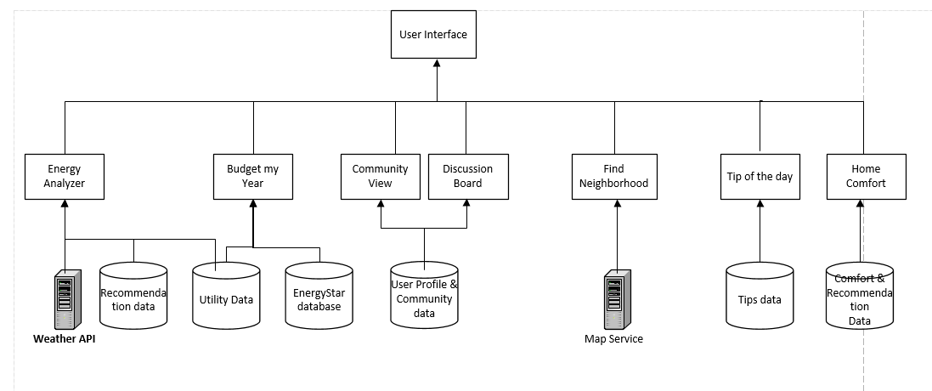

**Use Case Diagram:**

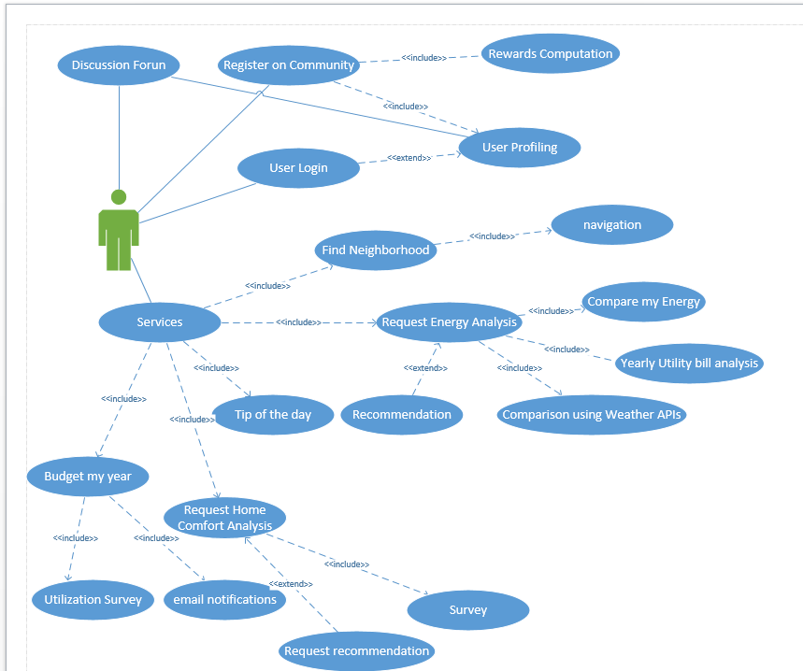

**Class Diagram:**

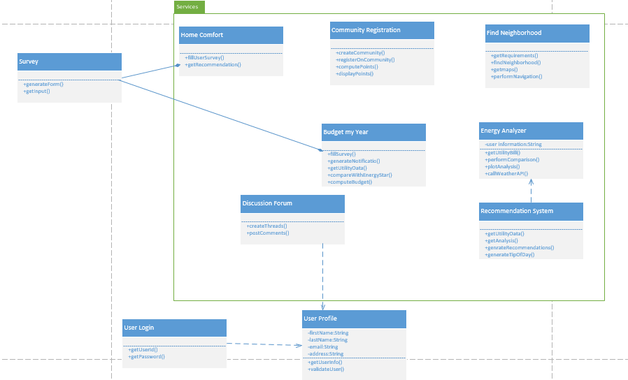

**5. Service Offerings:**

This application intends to provide the following services to the users.

* Analysis of Energy consumption of the household with recommendations on how to reduce it.
* Able to see the energy savings of other households in the same neighborhood and communicate with them through discussion boards.
* Finding the most economic neighborhood.
* Planning the budget.
* Email notifications.
* Recommendation on how to make home environment more comfortable

**6. Project Schedule:**

•   1st Phase Report: Mar. 7th   
•   2nd Phase Report: Mar. 21st   
•   3rd Phase Report: Apr. 11th   
•   4th Phase Report: Apr 25th   
•   Final project presentations: May 6th and May 8th   
•   Final project report: May 9th

1st Phase:

* Energy Analysis
  + Create user log-in
  + Create user registration
  + Create user interface for Home Comfort

2nd Phase:

* Recommendation System
* Develop user recommendation system
* Design Tip of the day interface
* Develop a discussion board

3rd Phase:

* Motivational System.
* Design My Neighbourhood interface
* Develop Interface for household of the month

4th Phase:

* Utility Budget
* Email Notification
* Budget my year

**Scrumdo:** <https://www.scrumdo.com/projects/umkc49/release/1013/stories>

**References:**

eSave Project, UMKC

<http://www.greenbuttondata.org/>

<http://energy.gov/energysaver/energy-saver>

<http://www.ase.org/resources/top-5-reasons-be-energy-efficient>

<http://www.ext.colostate.edu/pubs/consumer/10610.html>

<http://energy.gov/sites/prod/files/2013/06/f2/energy_savers.pdf>